“Heaven’s light is our guide”

**Rajshahi University of Engineering & Technology**

**Department of Computer Science & Engineering**

**Course No: CSE 3102**

**Course Title: Database System Sessional**

**Lab Report (Lab 2)**

|  |  |
| --- | --- |
| Submitted By:  ***Saifur Rahman***  *Roll No:* ***1703018***  *Section: ’17-A*  *Class:3nd year (Odd Semester)* | Submitted To:  ***Dr. MD. Ali Hossain***  *Associate Professor,*  *Dept. of CSE,*  *RUET.* |

***Date of Experiment: 17thJanuary, 2021***

***Date of Submission: 24th January, 2021***

**INDEX**

|  |  |  |
| --- | --- | --- |
| **Serial No** | **Topics** | **Page no** |
| 1 | Introduction to the problem | 01 |
| 2 | Problem Statement | 01 |
| 3 | Designed Database | 02 |
| 4 | Submitted Queries | 03 |
| 5 | Output | 05 |
| 6 | Conclusion | 07 |

Introduction to the problem

The problem is about a **customer-sale** scenario where we need to store and manipulate data within database.

A **database** is a collection of information that is organized so that it can be easily accessed, managed and updated. Computer **databases** typically contain aggregations of data records or files, containing information about sales transactions or interactions with specific customers.

A **database management system** (**DBMS**) is a software package designed to define, manipulate, retrieve and **manage** data in a **database**. A **DBMS** generally manipulates the data itself, the data format, field names, record structure and file structure. It also defines rules to validate and manipulate this data.

Problem statement

**Database Schema:**

Customer (Cust id : integer, cust_name: string)

Item (item_id: integer, item_name: string, price: integer)

Sale (bill_no: integer, bill_date: date, qty_sold: integer)

Relation_c_i (cust_id, item_id)

Relation_c_s (cust_id, bill_no)

The problem is to perform the following:

* Creating table and inserting records
* Designing relationship set tables
* Listing the bill details with quantity sold, total price of the items
* Listing the total bill details with customer name, quantity sold and total billable amount

objectives

* Learning about Database
* Learning about Database Management System (DBMS)
* Creating and manipulating Database
* Performing Queries to the Database

Designed database

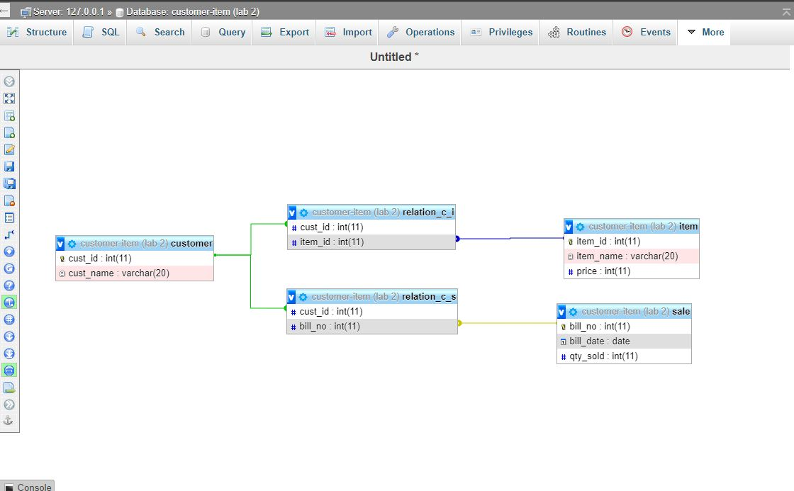

Fig 2.1: Database design for billing details with quantity sold, total price of the items

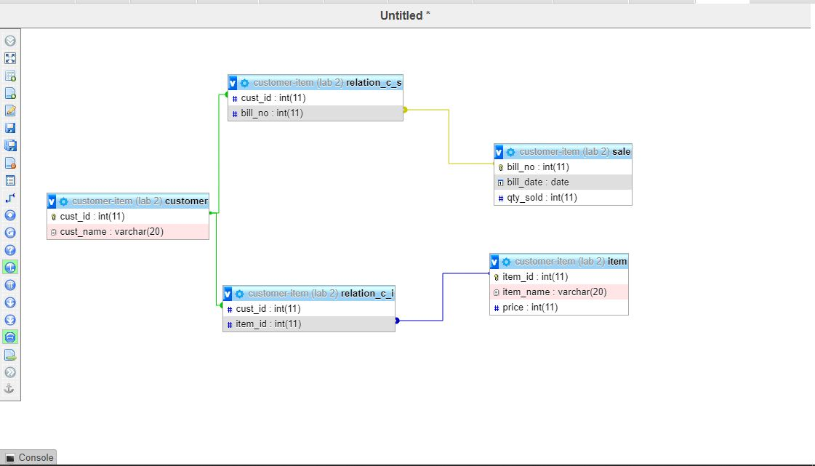

Fig 2.2: Database design for billing details with customer name, quantity sold and total billable amount

**Submitted queries**

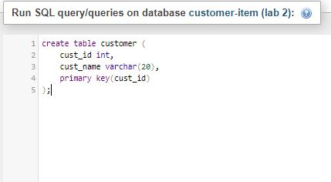**Creation of Tables:**

Fig 2.3: Customer Table Creation

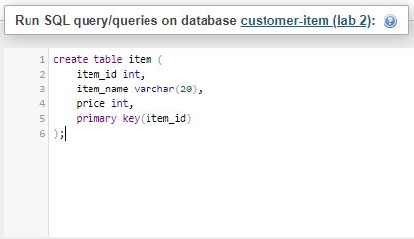

Fig 2.4: Item Table Creation

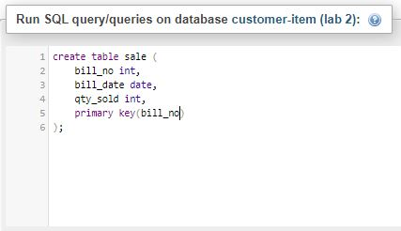

Fig 2.5: Sale Table Creation

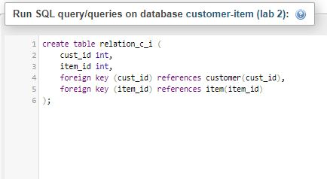Fig 2.6: Relation Customer Item Table Creation

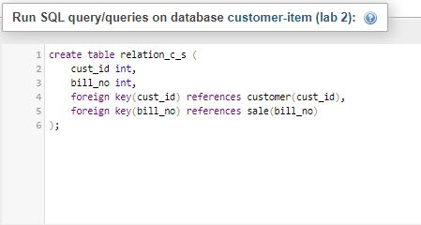

Fig 2.7: Relation Customer Sales Table Creation

**Insertion:**

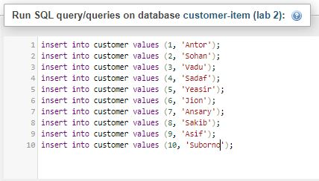

Fig 2.8: Customer Table Insertion

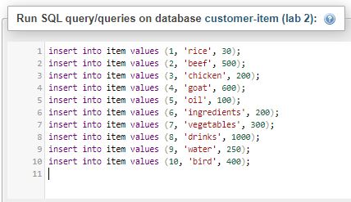

Fig 2.9: Item Table Insertion

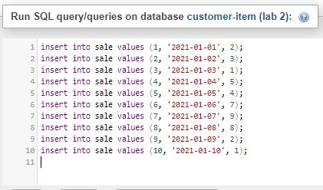Fig 2.10: Sales Table Insertion

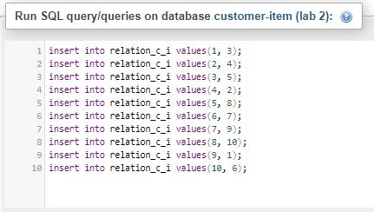

Fig 2.11: Relation Customer Item Table Insertion

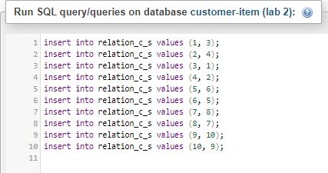

Fig 2.12: Relation Customer Sale Table Insertion

Outputs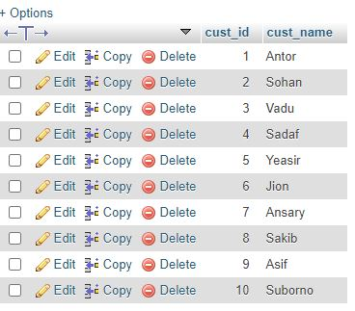

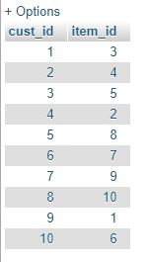

Fig 2.13: Customer Table

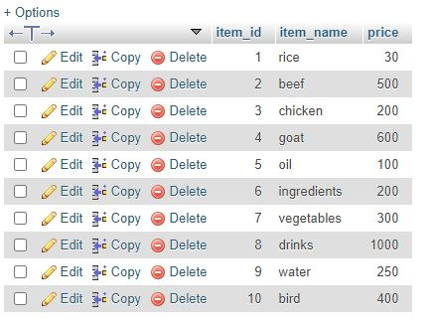Fig 2.14: Item Table

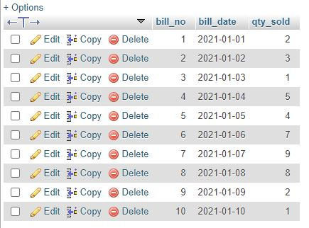Fig 2.15: Sale Table

Fig 2.16: Relation Customer Item Table

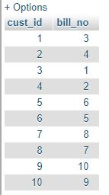

Fig 2.17: Relation Customer Sale Table

**Output of Performed Queries**

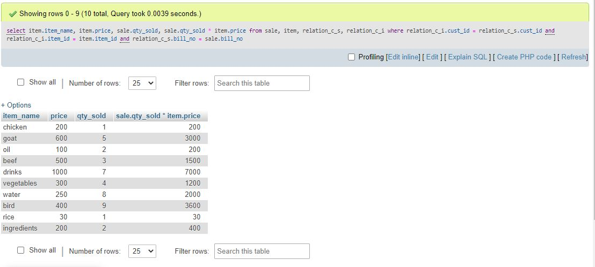

Fig 2.18: Billing Details with the Quantity Sold, Total Price of the Items

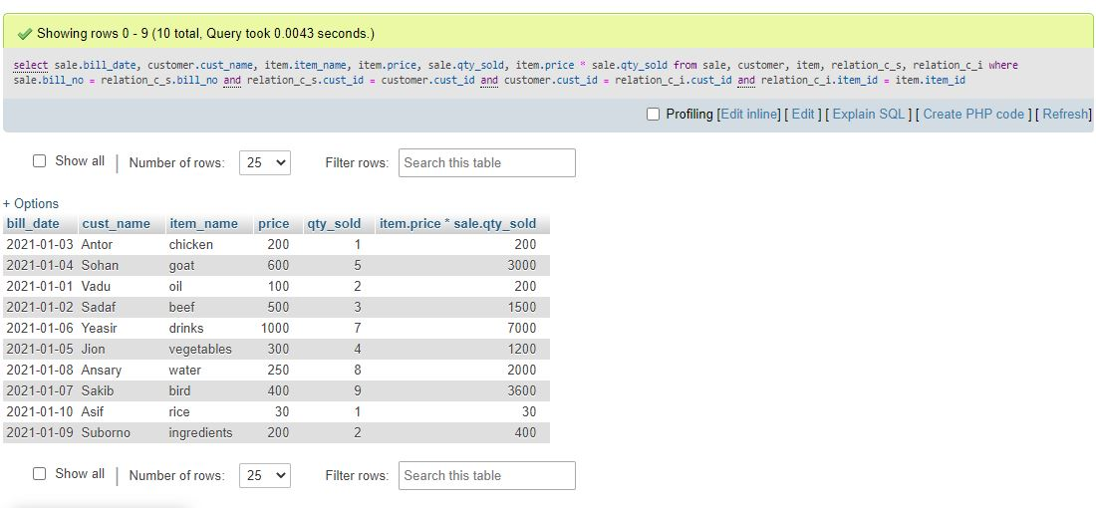

Fig 2.19: Billing Details with the Customer Name, Quantity Sold and Total Billable Amount

Conclusion

Databases are mainly based on various data tables which are connected with each other through another relationship set table. The queries performed on the database are mainly based on the relationship table. The relationship tables take primary keys of one table and connects to another primary key of another table. So, to find a specific query between two or more tables one just needs to identify the relation between them and perform the operation according to it. In this Database I’ve connected three data tables together with two relationship sets and connected their primary keys to find out the query I wanted.